Software Construction

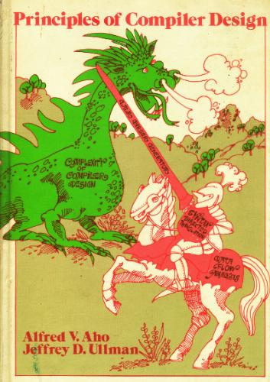

Level: Undergraduate

Instructor: Ayesha Naseer

Course Description: This course is about how to build a compiler. The main areas covered are:
- Lexical analysis (tokenizing)
- Syntactical analysis (parsing)
- Code generation
- Code optimization
Syllabus

Course Meeting Timings:
16 B
Monday: 11:00 to 11:50
Tuesday: 01:20 to 03:10

Lectures:

Attendance at lectures is mandatory and you are expected to show up prepared to answer questions and participate in discussion.

Prerequisites:

Students should have taken Data structures and Algorithms, automata, programming languages, computer architecture, and operating systems. If you do not have experience in these subjects and would like to take the course, please contact the instructor.

Grading
The grading breakdown is as follows:
Activities | percentages
Assignments | 10%
Quizzes | 10%
1st OHT | 15%
2nd OHT | 15%
Final | 50%

Collaboration Policy:

For problem sets and labs, you are allowed to discuss your answers with other students, but please write up your own answers and list your collaborators. Copying solutions from other students is never allowed. For the group project you will work in teams and hand in only one written report.

Text
The course readings will primarily be drawn from the following sources:
1. Principles of Compiler Design, by Alfred Aho and Jeffrey D. Ullman,

Supplemental Readings
Class notes are available on LMS.

Calendar

Week | Topics
1 | Structure of Compilers
2 | Lexical Analyzer
3 | Lexical Analyzer Generators  ( Flex)
4 | Semantic Analysis
5 | Introduction to parsing techniques
6 | OHT-1
7 | Top-down parser
8 | LL(1) grammars
9 | Non-recursive predictive parsers
10 | Bottom-up parsers
11 | Shift-reduce parsing/ Handle puring
12 | OHT-2
13 | Canonical LR(1) parsing tables
14 | Yacc parser generator
15 | Code generation
16 | Final Exam

